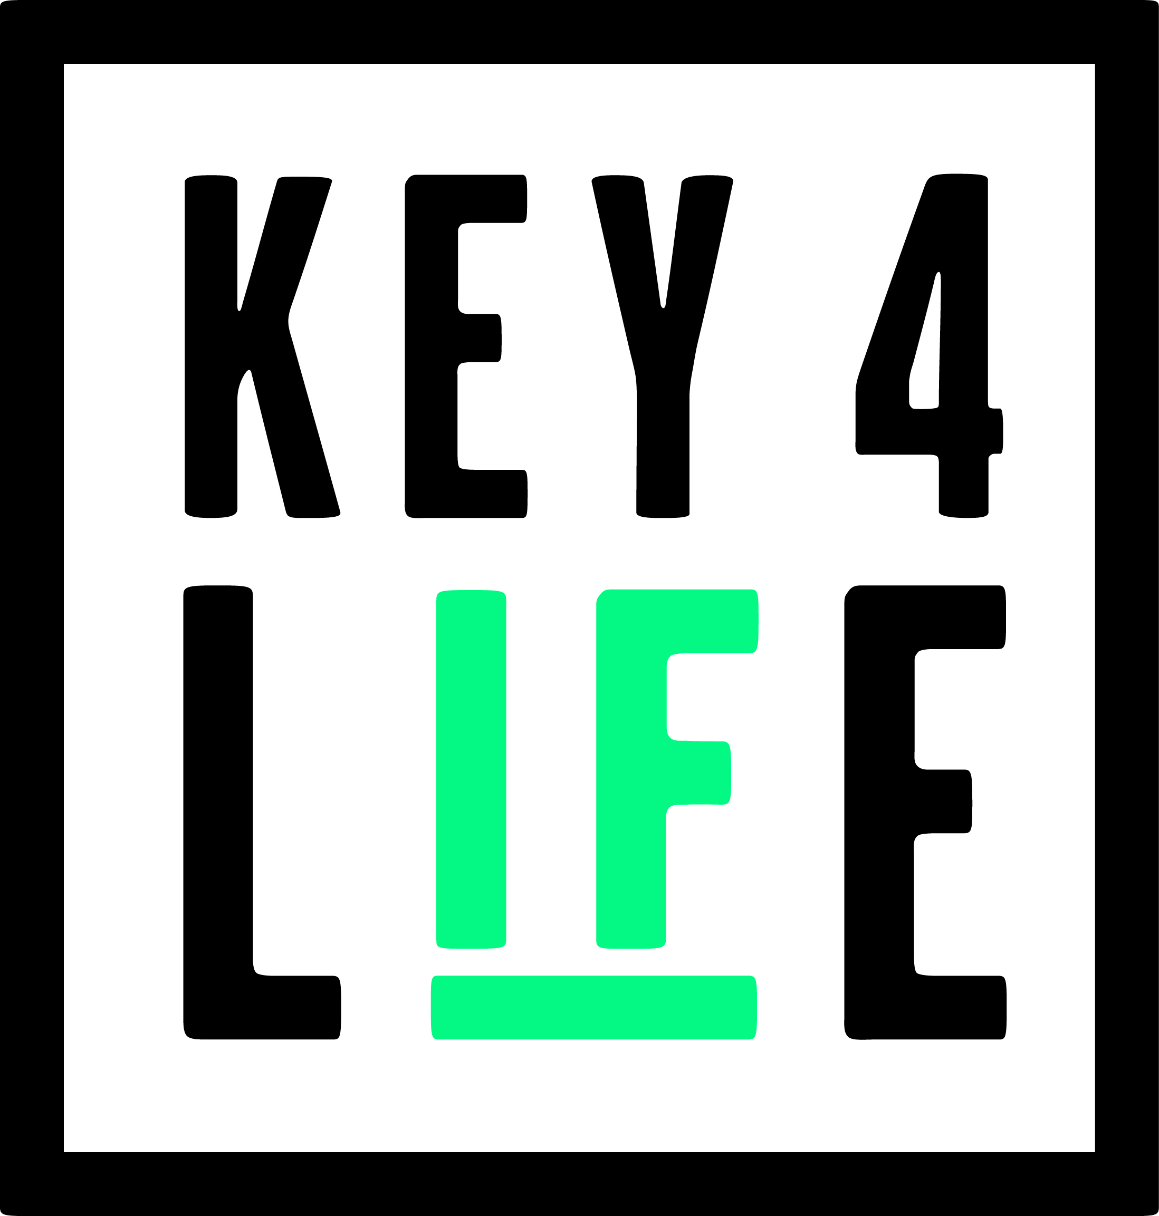

BOOKING FORM - CORPORATE PACKAGES

KEY4LIFE 2023 GALA DINNER
Wednesday, 1st November 2023
The Lindley Hall, 80 Vincent Square, London SW1P 2PB

Title: | Name: | Company:
Telephone:
Email:

PACKAGE TYPE - (Tick chosen option)
I would like to Sponsor a Corporate Table @ £4,995

Table Host Name: …………………………………………
Please include table guest’s full name, dietary requirements and email address below:

ATTENDEES | Dietary Requirements | Email Address (for e-ticket)
1.
2.
3.
4.
5.
6.
7.
8.
9.
10.

We ask that you please return this form by 22nd September 2023 to sarah.pollard@key4life.org.uk.

If you have any queries, please contact:
Sarah Pollard.
Email: sarah.pollard@key4life.org.uk
Tel: 07494 499336
Or call the Key4Life office: 0117 941 5858
Registered Charity No. 1152426

